Congratulations! Now you can use Stripe payment gateway on your dating site using WPDating Plugin! To set-up the Stripe payment add-on, please go through this manual.

First create a Stripe Account at https://stripe.com/ and then go through the following procedure as mentioned below :
Step 1: Login to your WordPress admin dashboard.
Step 2: Goto DSP Admin => DSP Stripe (refer to the below image)
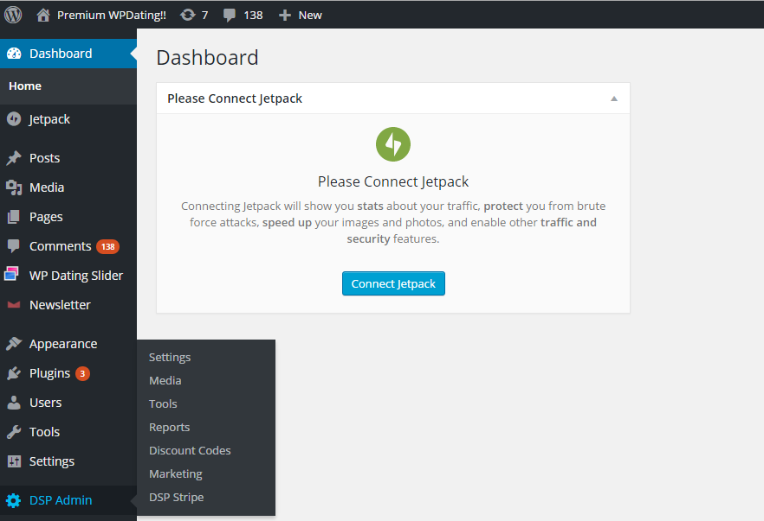

You will find these keys from your stripe account @ stripe.com
Step 3: Enter the Live Secret Key for your Stripe account.
Step 4: Enter the Live Publishable Key for your Stripe account.
Step 5: Enter the Stripe Currency
Step 6: And Click on save changes (refer to the below image)

Now, your Stripe Payment Set up has been configured. As you can see, you will also be able to find the payment summary received by the clients too.
